SIMATS ENGINEERING
ASSESSMENT TOOL 3

COURSE NAME: COMPUTER NETWORKS

COURSE CODE: CSA0714

NAME: Keerthana R

REG NO:192524489

COURSE OUTCOME COVERED

CO4:
Design network topologies star, mesh, bus, and hybrid using networking devices, transmission media, and cabling standards (BL2,BL6)

Assessment Tool Weightage: 30%

QUESTIONS: 5 Total Marks:25
Annexure A

Comparative Analysis
- Star topology is generally more expensive than bus topology because it requires a central device such as a switch or hub and more cabling to connect each node individually. In contrast, bus topology uses a single backbone cable, making it low-cost and easier to install. However, in terms of reliability, star topology is superior because failure of one node does not affect others, whereas a failure in the main bus cable can bring down the entire network. Performance is also better in star topology since data transmission is managed through a central device, reducing collisions, while bus topology suffers from performance degradation as more devices are added due to increased data traffic on the shared medium.
- Mesh topology offers very high fault tolerance because every node is connected to multiple other nodes, providing multiple paths for data transmission. If one link fails, data can still be routed through alternate paths without disrupting communication. In contrast, star topology has moderate fault tolerance; while failure of individual nodes does not affect the network, failure of the central hub or switch can cause the entire network to stop functioning. Therefore, mesh topology is more robust and reliable in critical environments compared to star topology.
- Bus topology is simple and easy to install because it uses a single backbone cable with minimal connections, making it suitable for small networks. On the other hand, mesh topology is highly complex to install as each node must be connected to every other node, requiring a large number of cables and ports. This complexity increases significantly as the number of devices grows, making mesh topology time-consuming and costly to implement compared to the straightforward setup of bus topology.
- Hybrid topology is highly scalable because it combines two or more different topologies (such as star, mesh, or bus), allowing the network to expand flexibly according to organizational needs. New segments can be added without affecting the existing network structure. In comparison, star topology is also scalable but to a limited extent, as it depends on the capacity of the central device (switch or hub). Once the central device reaches its port limit, expansion requires additional hardware. Thus, hybrid topology provides greater scalability than star topology.
- In terms of maintenance, star topology is relatively easy to manage because issues can be quickly identified and isolated to a specific node or cable. Mesh topology, while highly reliable, is difficult to maintain due to its complex structure and large number of connections, making troubleshooting time-consuming. Bus topology is harder to maintain than star because faults in the backbone cable can disrupt the entire network and are difficult to locate. Hybrid topology has moderate maintenance complexity; while it benefits from flexibility, managing multiple combined topologies requires careful monitoring and skilled administration.

RUBRICS FOR CALCULATION

Criteria | Weightage | Exemplary (4) | Proficient (3) | Developing (2) | Beginning (1)
Understanding of Concepts | 15% | Demonstrates complete and indepth  understanding of all concepts being compared | Good understanding with minor gaps | Basic understanding; some concepts unclear | Poor understanding of concepts
Comparison Depth | 20% | Provides detailed, insightful, and meaningful comparisons across multiple aspects | Adequate comparison with relevant points | Limited comparison; lacks depth | Minimal or incorrect comparison
Criteria  Selection | 10% | Selects highly relevant and appropriate comparison parameters | Mostly relevant criteria | Some irrelevant or missing criteria | Poor or no criteria selection
Analytical Skills | 15% | Strong analysis with logical reasoning and clear justification | Good analysis with some  justification | Basic analysis with weak reasoning | No clear analysis
Organization & Structure | 10% | Well-organized, clear, and logically structured | Generally organized | Somewhat disorganized | Poorly structured
Use of  Examples /  Evidence | 10% | Uses strong, relevant examples or data to support comparison | Uses some examples | Limited examples | No supporting examples
Clarity of  Presentation | 10% | Very clear, concise, and easy to understand | Mostly clear | Somewhat unclear | Difficult to understand
Conclusion &  Insights | 10% | Insightful conclusion with strong justification | Clear conclusion | Basic conclusion | No or weak conclusion

- Star topology is generally more expensive than bus topology because it requires a central device such as a switch or hub and more cabling to connect each node individually. In contrast, bus topology uses a single backbone cable, making it low-cost and easier to install. However, in terms of reliability, star topology is superior because failure of one node does not affect others, whereas a failure in the main bus cable can bring down the entire network. Performance is also better in star topology since data transmission is managed through a central device, reducing collisions, while bus topology suffers from performance degradation as more devices are added due to increased data traffic on the shared medium.

ANSWER:

Star-Topology:
In a star topology, each computer or network device is connected to a central switch or hub. The central device controls communication between the connected devices. This topology provides better fault isolation, easy troubleshooting, and good network performance. However, the failure of the central switch or hub can affect the entire network. It also requires more cables, making it more expensive than bus topology.

Bus-Topology:
In a bus topology, all devices share a common backbone cable through which data is transmitted. It requires less cable and fewer networking devices, making it simple and inexpensive to install. However, network performance decreases when many devices are connected because all devices share the same communication medium. A fault in the backbone cable can also interrupt the entire network.
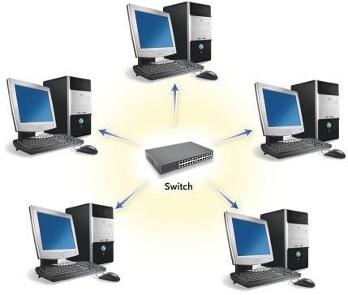

Explanation: All devices are individually connected to a central switch/hub. If one node or its cable fails, the remaining devices can continue communicating
Figure 1: Star Topology

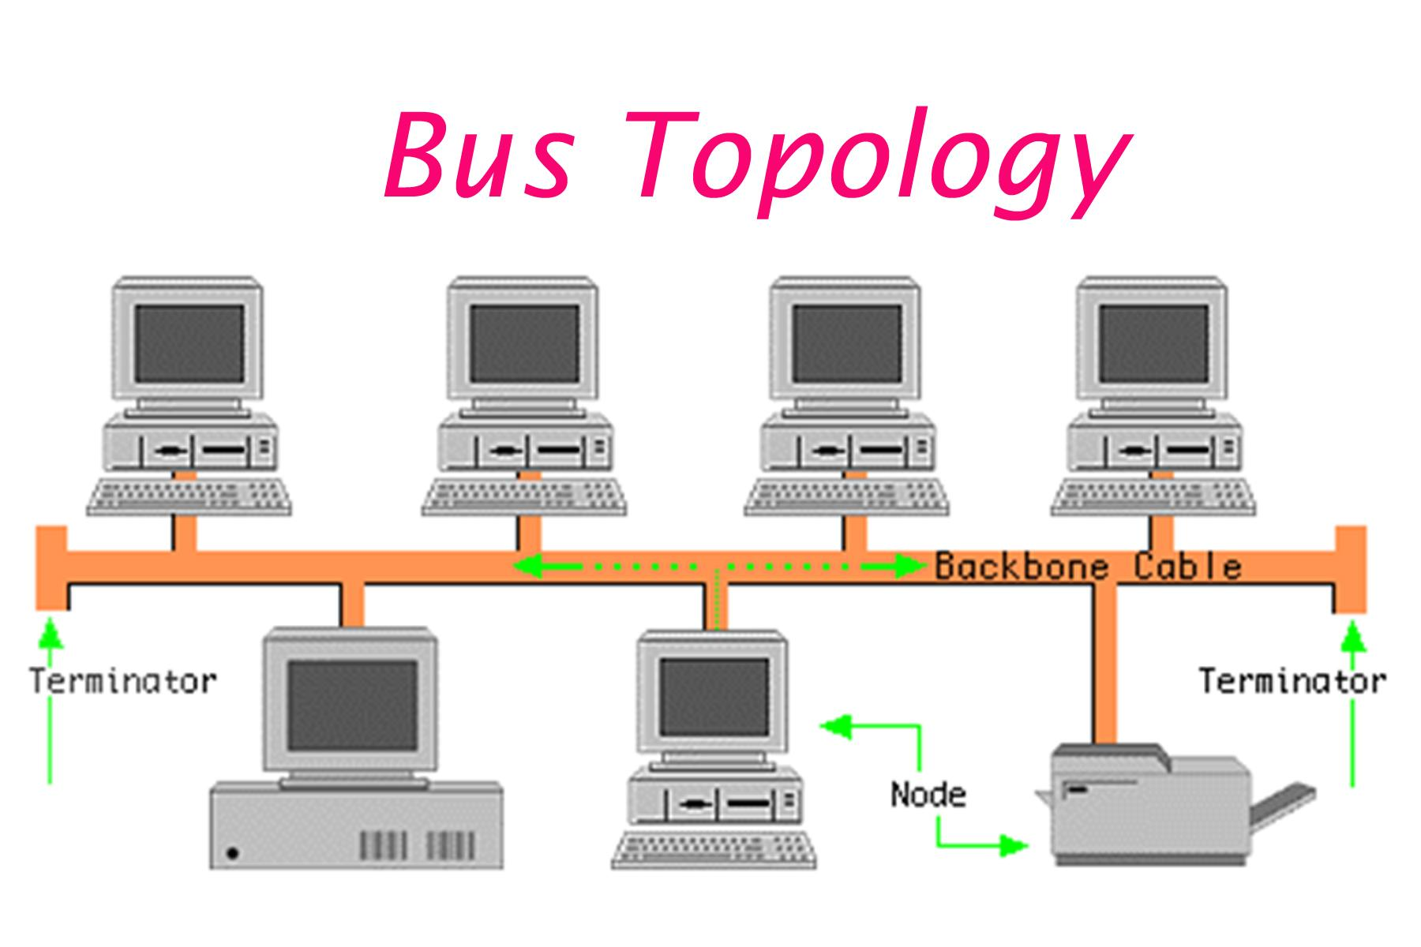

F figure 2: Bus topology

- All computers are connected to a single backbone cable.
- Uses less cabling and is cheaper.
- If the backbone cable fails, the entire network can be affected.

2)Mesh topology offers very high fault tolerance because every node is connected to multiple other nodes, providing multiple paths for data transmission. If one link fails, data can still be routed through alternate paths without disrupting communication. In contrast, star topology has moderate fault tolerance; while failure of individual nodes does not affect the network, failure of the central hub or switch can cause the entire network to stop functioning. Therefore, mesh topology is more robust and reliable in critical environments compared to star topology.

Answer:

Mesh topology:

offers very high fault tolerance because each node is connected to multiple other nodes, creating several possible paths for data transmission. If one connection fails, data can be transmitted through an alternative path, so communication can continue without major disruption.
star topology:

provides moderate fault tolerance. If one individual node or its connecting cable fails, the other nodes continue to operate normally. However, if the central hub or switch fails, the entire network may stop functioning because all communication depends on the central device.

Therefore, mesh topology is more robust and reliable than star
topology, especially in critical environments where continuous
communication and high network availability are required. However,
mesh topology is more expensive and complex to install because it
requires more cables and connections.

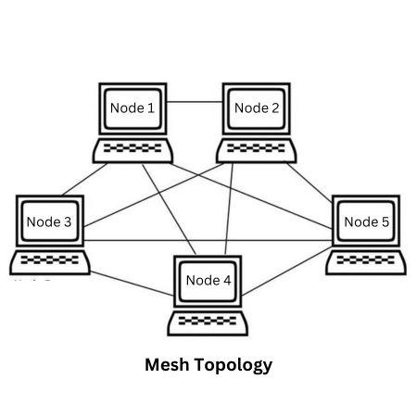

Figure :1 MESH Topology

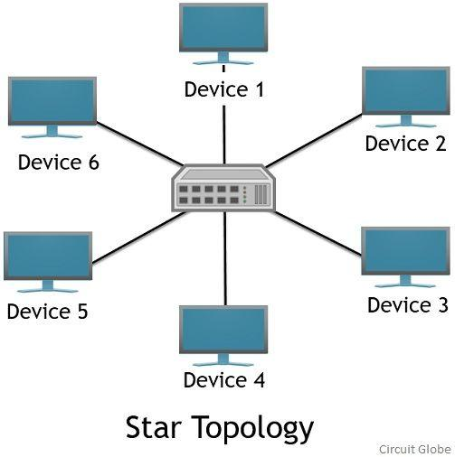

Figure:2 STAR Topology

3.Bus topology is simple and easy to install because it uses a single backbone cable with minimal connections, making it suitable for small networks. On the other hand, mesh topology is highly complex to install as each node must be connected to every other node, requiring a large number of cables and ports. This complexity increases significantly as the number of devices grows, making mesh topology time-consuming and costly to implement compared to the straightforward setup of bus topology.

ANSWER:

Bus topology:

Is simple and easy to install because all devices are connected to a single backbone cable. It requires less cabling and fewer connections, which reduces installation cost and complexity. It is suitable for small networks where only a limited number of devices are connected. However, if the main backbone cable fails, the entire network can be affected.

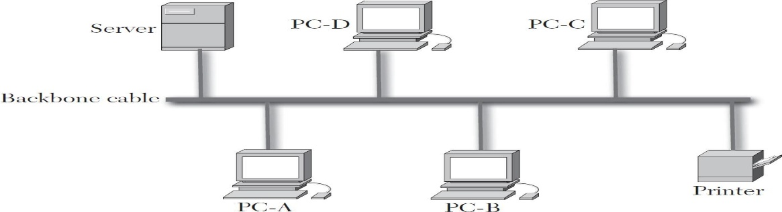
Single backbone cable connecting multiple devices, resulting in a simple and low-cost installation.
FIGURE 1: BUS TOPOLOGY

Mesh topology:
Is more complex to install because each device is connected directly to every other device in a fully connected mesh. Therefore, as the number of devices increases, the number of cables and connections increases rapidly. A fully connected mesh with n devices requires n(n−1)/2 connections, making it more time-consuming, difficult, and expensive to install than a bus topology

Multiple connections between devices, providing high reliability but increasing installation complexity.

- Hybrid topology is highly scalable because it combines two or more different topologies (such as star, mesh, or bus), allowing the network to expand flexibly according to organizational needs. New segments can be added without affecting the existing network structure. In comparison, star topology is also scalable but to a limited extent, as it depends on the capacity of the central device (switch or hub). Once the central device reaches its port limit, expansion requires additional hardware. Thus, hybrid topology provides greater scalability than star topology.

ANSWER:

Hybrid topology:

is highly scalable because it combines two or more different network topologies, such as star, bus, and mesh. This allows organizations to expand different sections of the network according to their requirements. New network segments can be added without significantly affecting the existing network, making hybrid topology suitable for large and growing networks

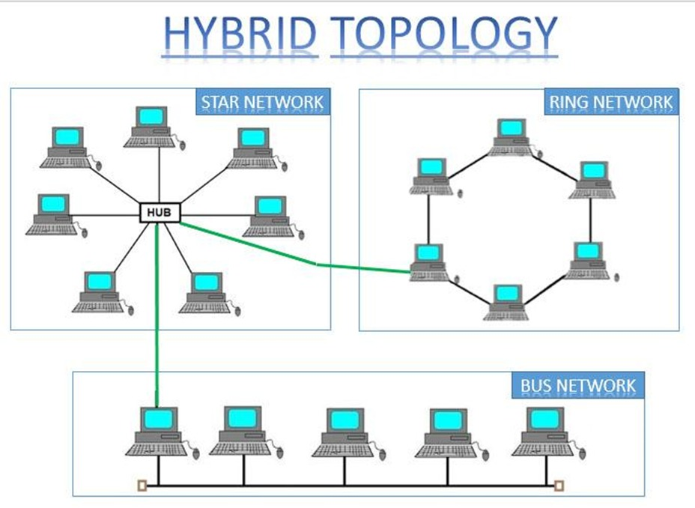
Hybrid Topology:
• Combines two or more different topologies.
• Different sections can use different network structures.
• New sections can be added according to requirements.
• Provides greater flexibility and scalability.

Star topology:

is also scalable, but its expansion is limited by the capacity of the central device, such as a switch or hub. When all available ports are occupied, additional switches or hubs are required to connect more devices. Therefore, expansion may require extra hardware and cost.

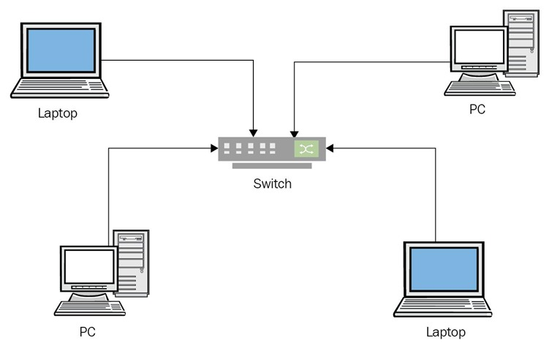

Star Topology:
• All devices are connected to a central switch or hub.
• New devices can be added easily if ports are available.
• When the ports are full, an additional switch or hub is required.
• Therefore, scalability is comparatively limited.

5) In terms of maintenance, star topology is relatively easy to manage because issues can be quickly identified and isolated to a specific node or cable. Mesh topology, while highly reliable, is difficult to maintain due to its complex structure and large number of connections, making troubleshooting time-consuming. Bus topology is harder to maintain than star because faults in the backbone cable can disrupt the entire network and are difficult to locate. Hybrid topology has moderate maintenance complexity; while it benefits from flexibility, managing multiple combined topologies requires careful monitoring and skilled administration.

ANSWER:

In terms of maintenance, star topology is the easiest to manage because each device has a separate connection to the central switch or hub. If a device or cable fails, the problem can usually be identified and isolated without affecting the other devices.

Mesh topology:

is highly reliable but difficult to maintain because every device has multiple connections with other devices. A large number of connections makes troubleshooting and repairing faults more complex and time-consuming.

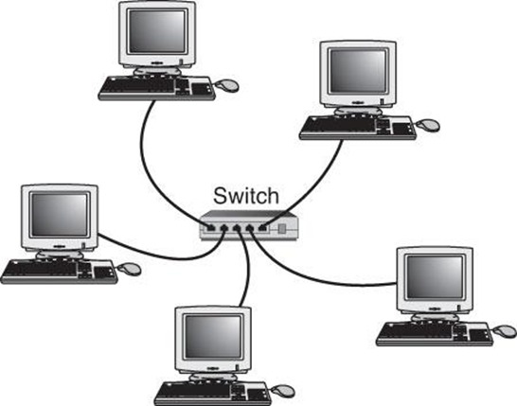

Bus topology:

is harder to maintain than star topology because all devices share a common backbone cable. If the backbone cable develops a fault, communication across the entire network can be disrupted, and locating the exact fault can be difficult.



Hybrid topology:

has moderate maintenance complexity because it combines two or more different topologies. Although it provides flexibility, administrators must monitor and maintain different network sections, which may require more technical knowledge.


Hybrid Topology:
• Combines different topologies.
• Each section may require different maintenance.
• Moderate maintenance complexity.

